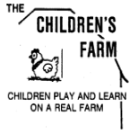
Summer on the Farm
Meet our incredible team!

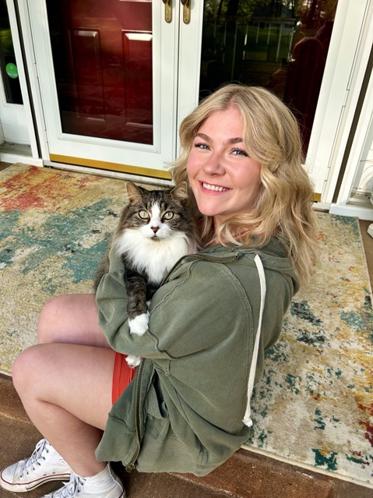
Korinn
(Teacher)

Hello! My name is Korinn and this is my second year as a summer teacher here at The Children’s Farm (and am also an alumni). I graduated from the University of Minnesota-Twin Cities with a BA in Psychology and am pursuing my Doctorate in Occupational Therapy at the UMN this Fall. I love playing and listening to music, reading, doing anything art related, playing with animals, and finding cute coffee and picnic places around the cities. I can’t wait to get another exciting summer started at the farm!

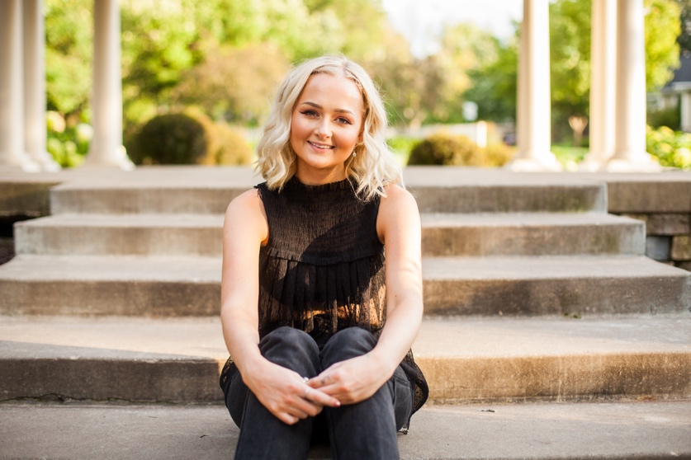
Ellie
(Teacher)

Hello! My name is Ellie Fisher and I am a returning summer teacher here at the Children’s Farm. I attended “farm school” myself when I was little for many years, and I have seen first-hand what an amazing place this is! I am in school at UW-River Falls, working to obtain two degrees by next spring, one in Psychology with an Emphasis in Mental Health and one in Art. I plan to then attend graduate school to acquire a master’s degree in Social Work and continue my work with children, education, animals, nature, art, and gardening, concurrently introducing therapeutic techniques. I love hiking, swimming, music, art, and exploring the outdoors. I am so excited to spend another memorable summer on the farm!

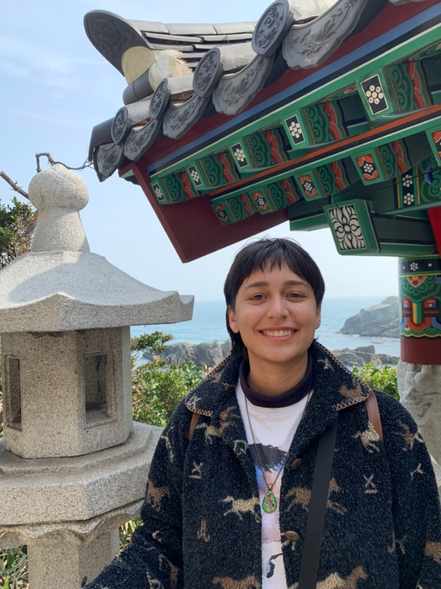
Yamuna
(Teacher)

Hi, I’m Yamuna, and this is my second summer as a teacher at the farm. I am a Bioproducts Engineering student at the University of Minnesota graduating this fall. I have been a junior counselor on many occasions and am very familiar with the farm. I love nature and interacting with the animals. I love art and being creative, and my favorite sport is soccer.

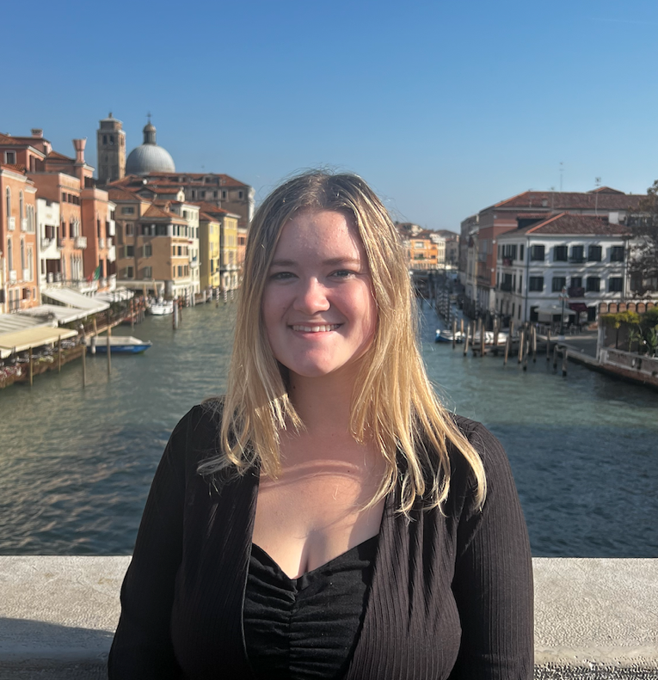
Jane
(Teacher)

Hello my name Jane. This will be my third summer working at the farm. I studied Early Childhood Education and Special Education at UMD. I enjoy teaching outdoors at the farm and love the excitement the kids have with the animals and fun outdoor activities. I went to The Children’s Farm as a kid and absolutely loved it. I can’t wait to meet everyone this summer!

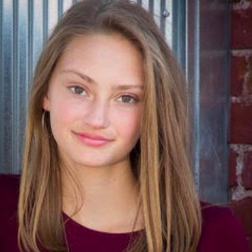
Erin
(Teacher)

My name is Erin Quam and I graduated from the College of St. Benedict in 2022 with a major in Psychology. I worked at the Children’s Farm last summer, and this past year I worked at another nature-based preschool in the twin cities. I am very passionate about working with children in an outdoor setting. In my free time I enjoy knitting, baking, and spending as much time outside as possible. I am very excited for this summer!

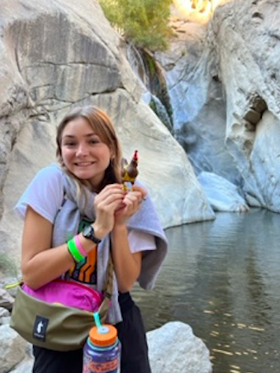
Ellie
(Teacher)

My name is Eleanor Quam. I am a recent college graduate and I am excited to spend the summer working at the farm! I am from Stillwater and attended the farm with my sister while growing up. I can’t wait to make more memories. I enjoy painting, dance, exploring, and spending time with loved ones in my free time. In the future, I would like to continue working in an outdoor environment with kids!

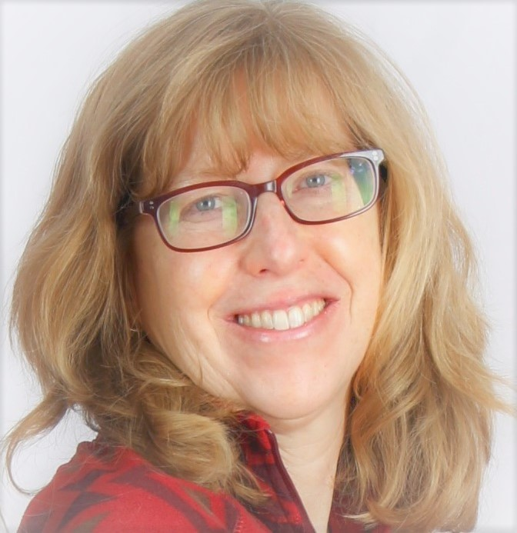
Brenda
(Garden Specialist)

I am excited to return to The Children's Farm as the summer gardener again this year! I love working with the kids and seeing their excitement and energy in the garden. Please stop by to say hello or let me know if you have any questions (or thoughts to share) about gardening! I live with my family in Minneapolis, where we have a 'small' summer garden, and 2 cats.

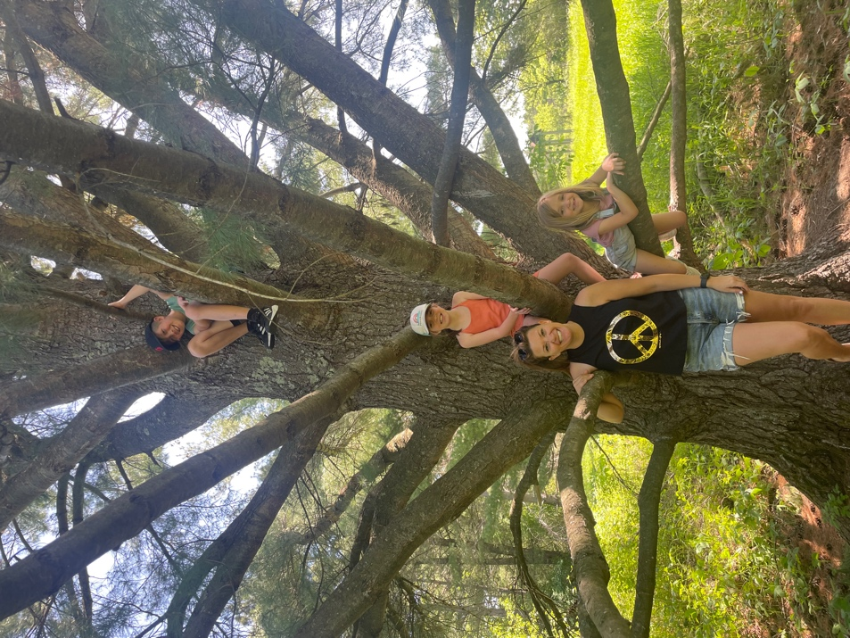
Amelia
(Summer Director)

Hi, my name is Amelia Gottschalk and my background is in Elementary Education. I love Minnesota summers and I am thrilled to be spending it on the Children’s Farm. I live in Stillwater with my husband Jake and 3 beautiful kids, Jack (10) Lucy (8) and Harper (6). I am so excited about the team of teachers joining us this summer! I can’t wait to get started and share my love for this farm and the outdoors with all the children and their families!

